Git and Github

1. Download Git for Windows at <https://git-scm.com/downloads>

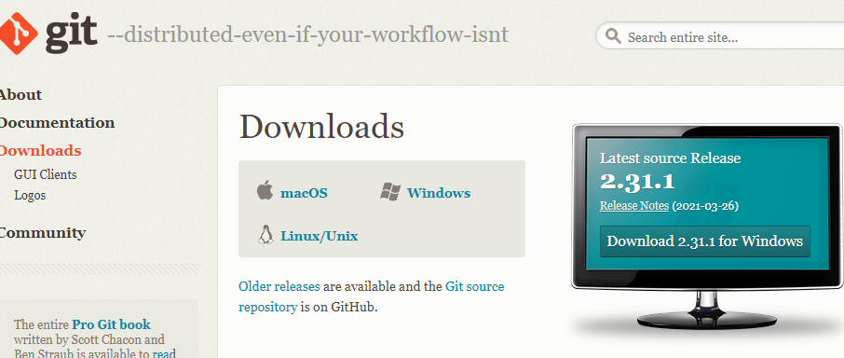

1. Create new folder on local. Git Bash on that folder.

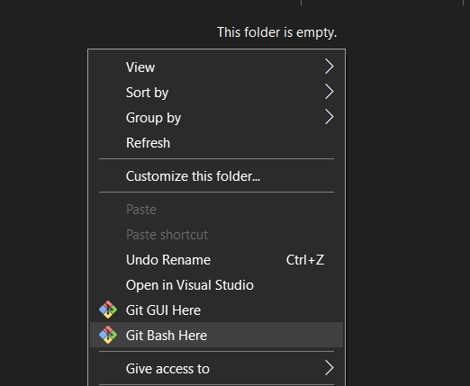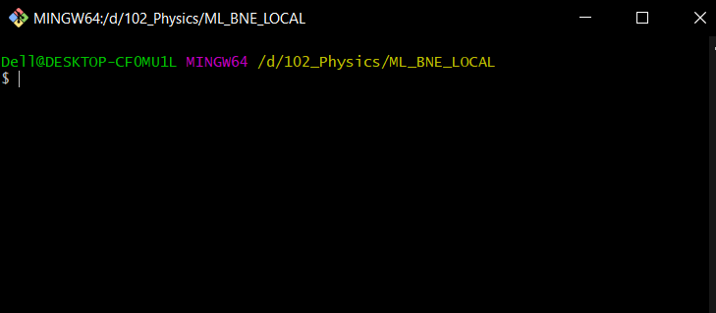

1. Open <https://github.com/miqbalrp/ML_bne> . Fork the repository to your own Github.

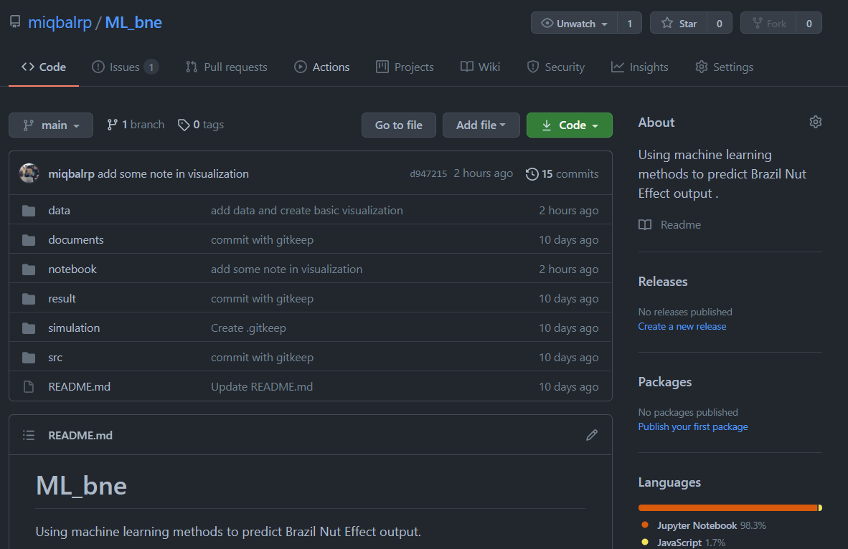

1. Copy the HTTPS URL

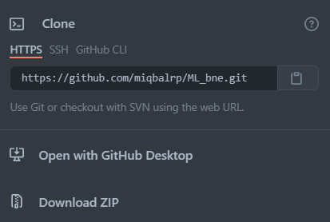

1. Back to Git Bash from local folder. Insert:

**git clone <url>**

